# CS 255 System Design Document Template

Vincent Messina

## UML Diagrams

### UML Use Case Diagram

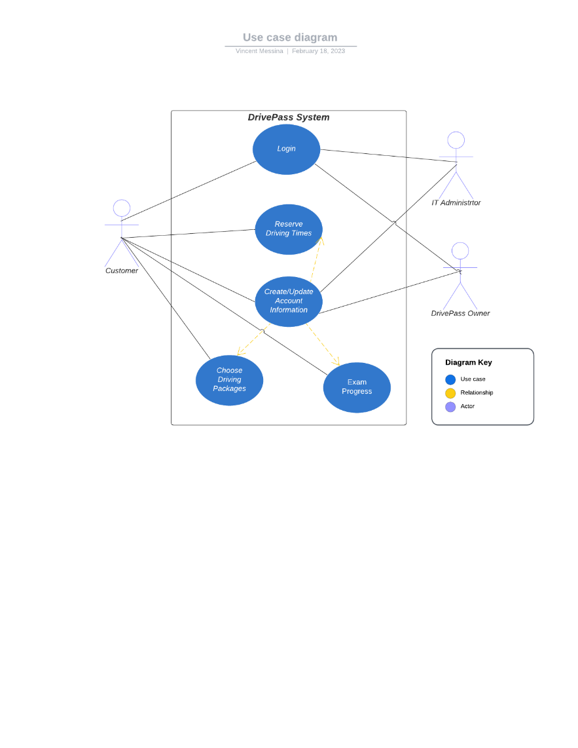

### UML Activity Diagrams

Schedule Appointments

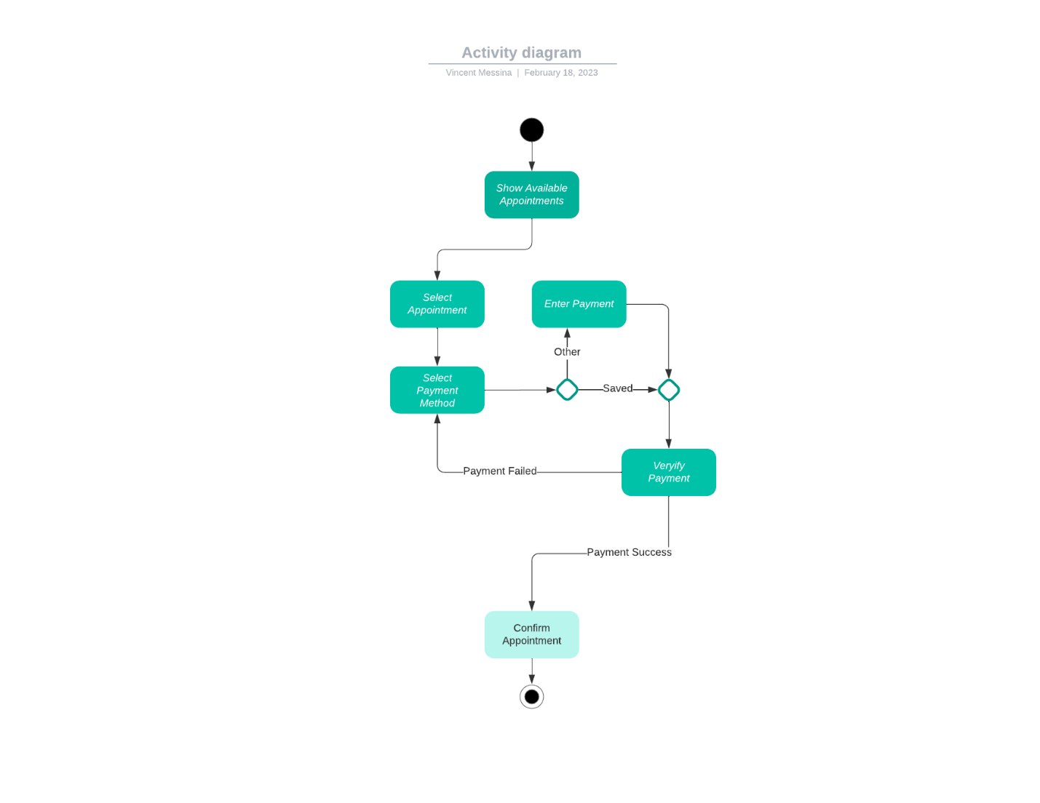

User Login

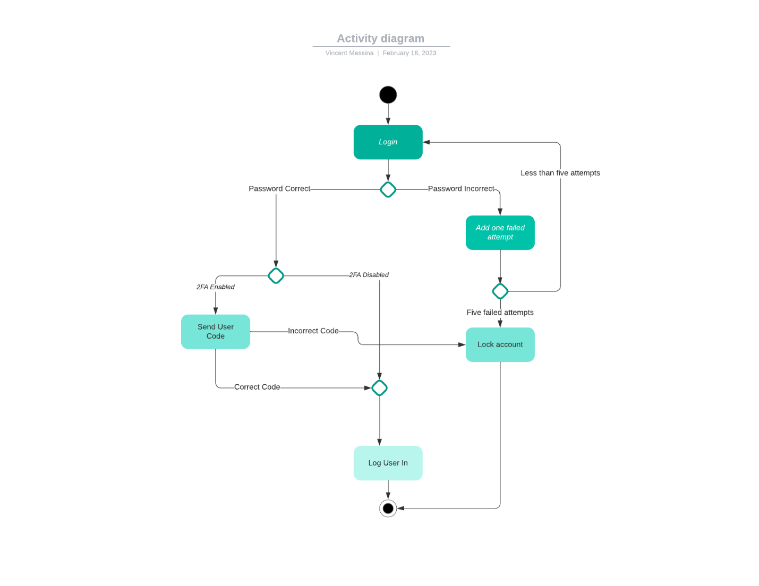

### UML Sequence Diagram

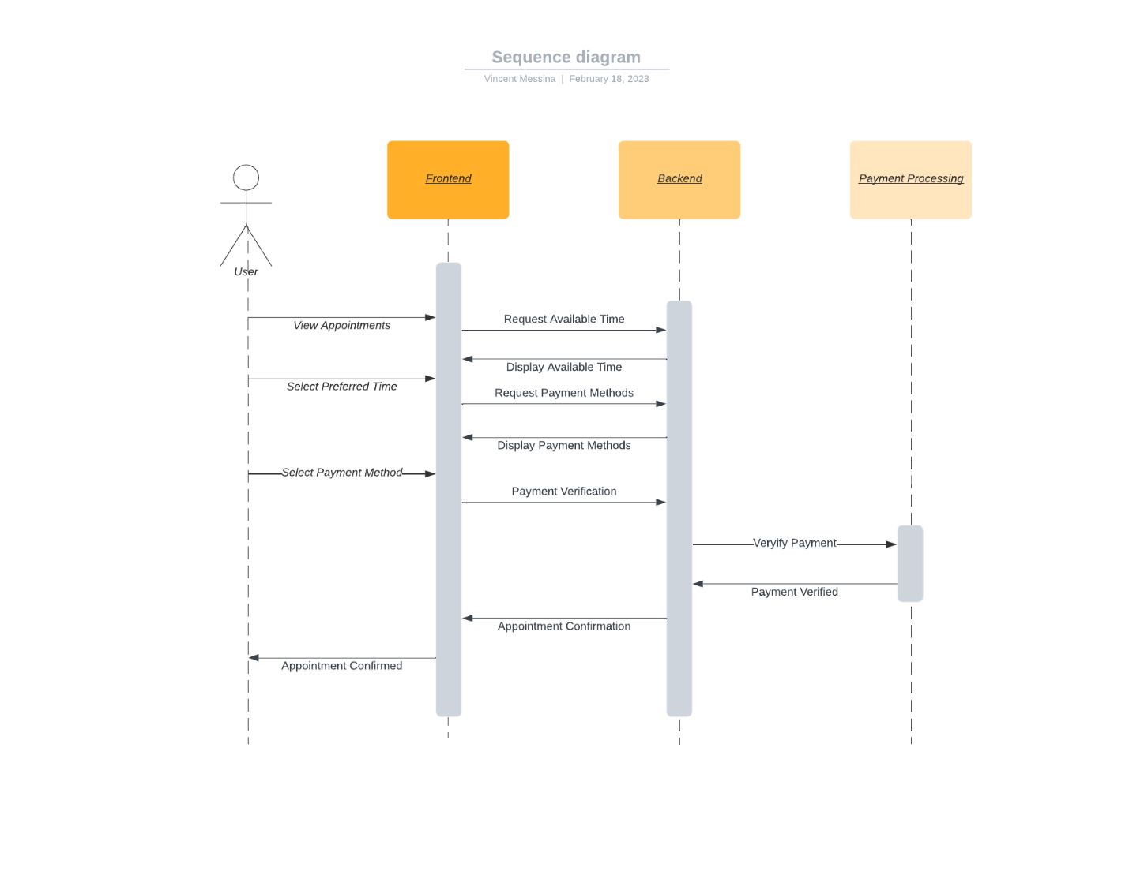

### UML Class Diagram

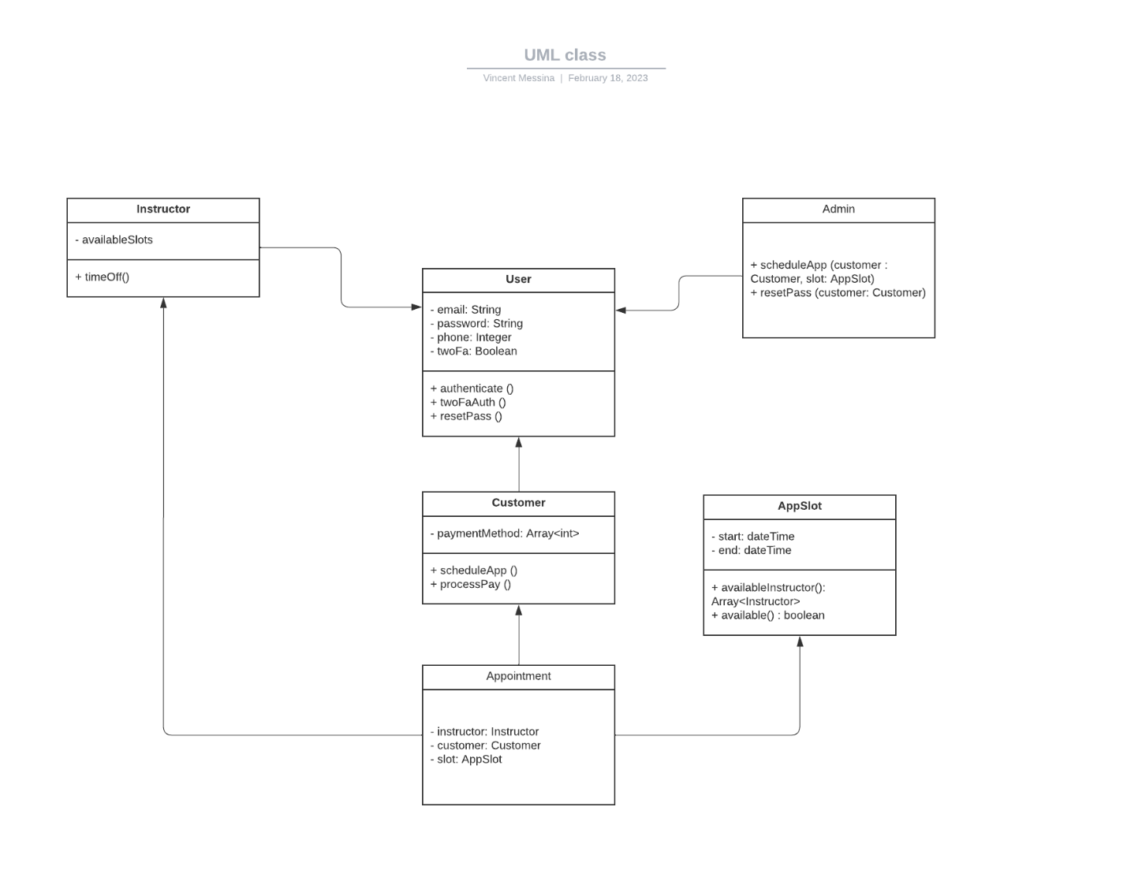

## Technical Requirements

* Internet
* Computer with web browser
* Payment
* Payment Processing Service
* Physical or cloud servers
* Domain name
* Operating System for server hosting
* Software Security
* Programming Software
* Server location if physical
* Cloud provider if digital servers